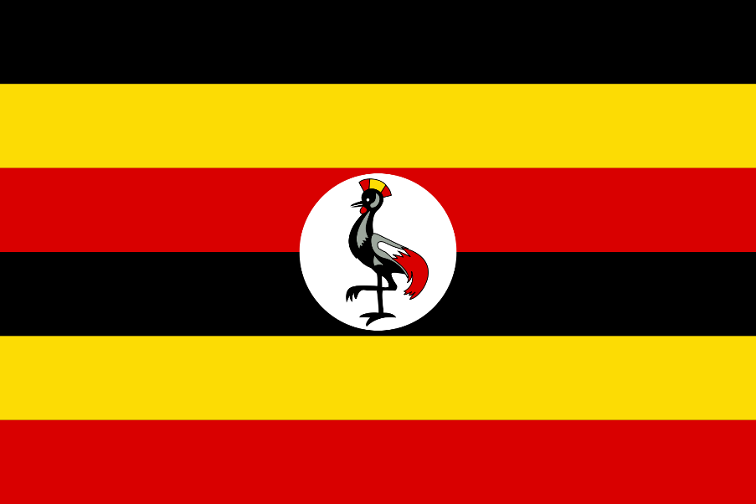 |  | Uganda  - Government  - 10/25/2014
THIS IS THE Ugandan Flag. https://upload.wikimedia.org/wikipedia/commons/thumb/4/4e/Flag_of_Uganda.svg/2000px-Flag_of_Uganda.svg.png |  | In This Issue: Uganda!

The Presidential Republic

Buganda was a British protectorate until it gained independence in 1995 and became Uganda, a presidential republic. Within the presidential republic the president of Uganda is the head of state and the head of the government. There are 38 registered parties. There are 3 branches within the government-the executive branch, the legislative branch, and the judicial branch. The system is based on a democratic parliamentary system with universal suffrage for all citizens 18 years and older.

The Executive Branch
The Executive Branch includes the President, the Vice President, the Prime Minister, and the Cabinet. The president is to be elected every 5 years.

The Legislative Branch
The power of the Legislative Branch is held by Parliament. Legislative elections are held every 5 years. In February of 2011 parliament had to redistrict and as a result grew from 332 to 375 members. This growth included 112 seats for women, 10 seats for military, 5 seats for youth, and 5 seats for people with disabilities.

The Judicial Branch
The Ugandan Judicial Branch operates separately from the other branches. This branch consists of four courts-the Magistrates Court, the High Court, the Court of Appeal (also known as the Constitutional Court), and the Supreme Court.

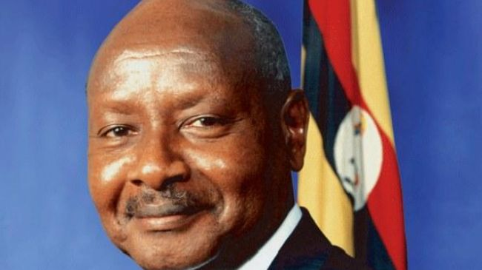
The President of Uganda
This is President Musevini. He has been in power since 1986, but was not elected president until 1996. He was then reelected in 2001, 2006, and 2011.
http://epmgaa.v-media.lionheartdms.com/img/photos/2014/02/24/Ugandan_President_Yoweri_Museveni_.jpg
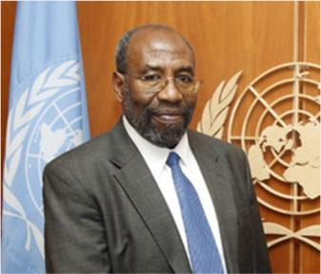
Prime Minister of Uganda
This is the Prime Minister of Uganda, Ruhakana Ruganda. He was elected in 2014, but held other Cabinet positions under Musevini since 1986.
http://blogdoambientalismo.com/wp-content/uploads/2011/07/Ruhakana-Rugunda.jpg

