Status of Education in Uganda
The United Nations has established three priorities for the reform of education worldwide: put every child in school, improve the quality of learning, and foster global citizenship (1). In order to further define what these priorities look like and provide ways to carry out these priorities the United Nations established the Education for All Goals, and the Millennium Development Goals. In order to determine if Uganda has met the three priorities set forth by the United Nations you must first determine if the country is meeting the goals set forth.
There are six Education for All Goals: expand early childhood care and education, provide free and compulsory primary education for all, promote learning life skills for young people and adults, increase adult literacy, achieve gender parity, and improve the quality of education (2). In the image below we see that Uganda is meeting the number one priority of putting every child in school because the country meets the Education for All Goals of both expanding early childhood care and education as well as provides free and compulsory primary education for all. In the graph we see that Uganda meets 107% gross rate of students in primary education. The percentage is over 100% due to the inclusion of over and under-aged students because of early or late school entrance as well as grade repetition (3).
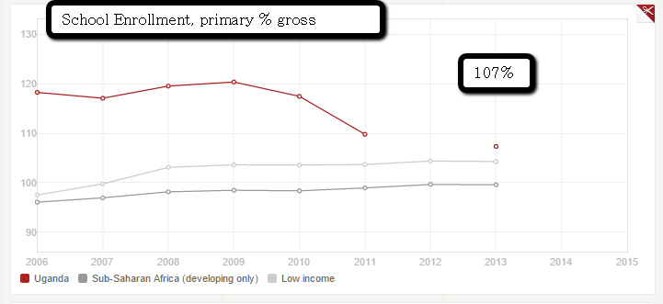
School Enrollment: Primary Gross %. Over 107% are enrolled in primary school.
http://data.worldbank.org/country/uganda
Uganda is also meeting the second priority of improving the quality of learning. We see this by Uganda meeting the goal of increasing the adult literacy in the country. We see this in the image below as the literacy rate rises from 56% to 73% between 1991 and 2010 (4).
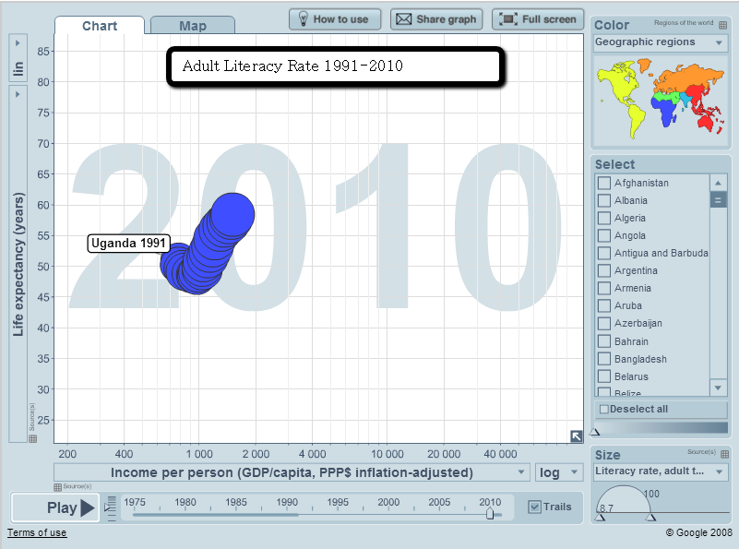
Adult Literacy Rate 1991-2012. The literacy rate rose from 56% to 73%.
http://www.gapminder.org/world/#$majorMode=chart$is;shi=t;ly=2003;lb=f;il=t;fs=11;al=0;stl=t;st=t;nsl=t;se=t$wst;tts=C$ts;sp=5.59290322580644;ti=2010$zpv;v=0$inc_x;mmid=XCOORDS;iid=phAwcNAVuyj1jiMAkmq1iMg;by=ind$inc_y;mmid=YCOORDS;iid=phAwcNAVuyj2tPLxKvvnNPA;by=ind$inc_s;uniValue=8.21;iid=pyj6tScZqmEdrsBnj2ROXAg;by=ind$inc_c;uniValue=255;gid=CATID0;by=grp$map_x;scale=log;dataMin=194;dataMax=96846$map_y;scale=lin;dataMin=23;dataMax=86$map_s;sma=49;smi=2.65$cd;bd=0$inds=i236_t001991,,,,
There are eight Millennium Development Goals: eradicate extreme poverty and hunger, achieve universal primary education, promote gender equality and empower women, reduce child mortality, improve maternal health, combat HIV/AIDS, malaria and other diseases, ensure environmental sustainability, and develop a global partnership for development (2). These goals contribute to the last priority, foster global citizenship. In this part we see that Uganda is failing to meet this priority and these goals. Not only is there a large divide in gender equality in Uganda, but HIV continues to be a large issue in the country. Between 1990 and 2011 the number of people newly in infected by HIV rose from 130,000 to 150,000 (5). No progress has been made to combat this. Uganda is also failing to gain environmental sustainability and develop a global partnership for development as it is plagued by war. Until these issues are solved the third priority will not be met.
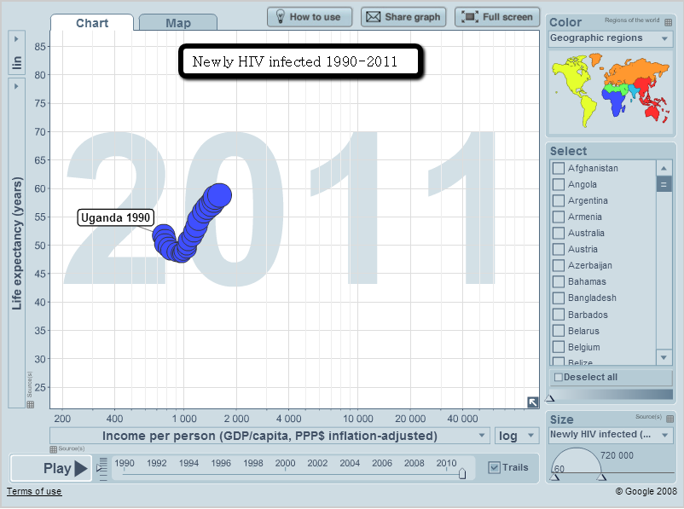
Newly HIV infected 1990-2011. The number of people infected by HIV rose from 130,000 to 150,000 from 1990-2011.
http://www.gapminder.org/world/#$majorMode=chart$is;shi=t;ly=2003;lb=f;il=t;fs=11;al=0;stl=t;st=t;nsl=t;se=t$wst;tts=C$ts;sp=5.59290322580644;ti=2015$zpv;v=0$inc_x;mmid=XCOORDS;iid=phAwcNAVuyj1jiMAkmq1iMg;by=ind$inc_y;mmid=YCOORDS;iid=phAwcNAVuyj2tPLxKvvnNPA;by=ind$inc_s;uniValue=8.21;iid=0ArfEDsV3bBwCdFk2WGhwakxTQkt4NUtTdFJDSlFHQ3c;by=ind$inc_c;uniValue=255;gid=CATID0;by=grp$map_x;scale=log;dataMin=194;dataMax=96846$map_y;scale=lin;dataMin=23;dataMax=86$map_s;sma=49;smi=2.65$cd;bd=0$inds=i236_t001800,,,,

Works Cited
(1) UN Global Education First Initiative – United Nations Secretary General's Global Initiative on Education – Education First. (n.d.). Retrieved October 25, 2015, from http://www.globaleducationfirst.org
(2) Resources for speakers, global issues, africa, ageing, agriculture, aids, atomic energy, children, climate change, culture, decolonization, demining, development, disabilities, disarmament, environment, food, governance, humanitarian, refugees, women. (n.d.). Retrieved October 25, 2015, from http://www.un.org/en/globalissues/briefingpapers/efa/
(3) Uganda. (n.d.). Retrieved October 25, 2015, from http://data.worldbank.org/country/uganda
(4) Share graph. (n.d.). Retrieved October 25, 2015, from http://www.gapminder.org/world/#$majorMode=chart$is;shi=t;ly=2003;lb=f;il=t;fs=11;al=0;stl=t;st=t;nsl=t;se=t$wst;tts=C$ts;sp=5.59290322580644;ti=2010$zpv;v=0$inc_x;mmid=XCOORDS;iid=phAwcNAVuyj1jiMAkmq1iMg;by=ind$inc_y;mmid=YCOORDS;iid=phAwcNAVuyj2tPLxKvvn
(5) Share graph. (n.d.). Retrieved October 25, 2015, from http://www.gapminder.org/world/#$majorMode=chart$is;shi=t;ly=2003;lb=f;il=t;fs=11;al=0;stl=t;st=t;nsl=t;se=t$wst;tts=C$ts;sp=5.59290322580644;ti=2015$zpv;v=0$inc_x;mmid=XCOORDS;iid=phAwcNAVuyj1jiMAkmq1iMg;by=ind$inc_y;mmid=YCOORDS;iid=phAwcNAVuyj2tPLxKvvn

